University of Waterloo

Department of Mechanical and Mechatronics Engineering

MTE 111

Lab 4: Thermal Effects in Metals and Polymers

Prof. Yimin Wu

Group #23: Ian Jinzo Macpherson Takeda, Joe Chen, Pedro Brossel, Randy Jayasinghe

July 28th, 2023

**SUMMARY**

During this lab, three experiments were performed. The first experiment was conducted to determine the creep regions from the strain-time graph of a Sn-Zn alloy wire. The measurements were conducted by recording three videos of different applied stresses to the wires until fracture. The values of strain were calculated using the extension readings obtained from the three videos.

After the experiment, it was concluded that as stress increases the strain at failure decreases. The reasons for this phenomenon were discussed and possible sources of error were explained based on graphs and tables created from readings taken during the tests.

The second experiment was conducted to study the strain-rate dependence of polymers. After the experiment, it was concluded that high strain rate decreases total strain because of a decrease in molecular mobility.

The third experiment was conducted to study the thermal effects on polymers when the temperature of the polymer was decreased below its glass transition temperature. It was concluded that the reason for the brittleness of the rubber band under low temperatures was because of the movement of chains becoming difficult.

**INTRODUCTION**

One of the purposes of this lab was to investigate the behaviour of Sn-Zn wires under various vertical loads. The objective was primarily to measure the strains experienced by the metal wires, and to plot these values on a graph. This graph was then used in subsequent calculations to obtain values such as the strain rate experienced by each wire in the secondary creep region. Further, measurements were taken of each wire’s linear dimensions, and these values were then used along with a predetermined load value to calculate the stress experienced by each wire to cause the strain observed during each experiment, as well as certain constants used in equations relating strain rate to stress. Additionally, the three stages of creep were mentioned, and their experimental equivalents were identified from the graphs obtained from earlier calculations. Finally, sources of error in the experiments were discussed and their impacts evaluated, and the effect of load on the creep observed was described and evaluated as well.

The second purpose of this lab was to investigate the behaviours of polymers under different strain rates and temperatures. This lab involved stretching a piece of “silly putty” with a slow rate of strain, and then stretching it with a much higher rate of strain. This led to the analysis of the putty’s behaviour under these different conditions, such as the manner of its stretching and the shape of its cross-sectional area after breaking. Further, the lab involved testing the elastic behaviour of a piece of natural rubber before and after being immersed in liquid nitrogen. The strain-rate dependence of the polymers was analysed and described, and possible reasons for the behaviours of the putty and the rubber were described and evaluated as well, along with research being done as to the molecular makeup of the polymers used in the lab.

**EXPERIMENTAL PROCEDURE:**

Experiment 1:

1. Measurement of materials: The three pieces of wire made of a Sn-Zn alloy had their diameters and original lengths measured. The diameter measurement was done in three different places along the wire, and the average of the values was calculated and logged (this was done to account for fluctuations in the dimensions of each specimen). Then, several loads were weighed and recorded in order to calculate the stress being applied to each wire.
2. Setup: Using the provided apparatus, the wire had one end wrapped around the ring where the masses were to be loaded. The other end was wound through the slit of the dead-load creep apparatus. Behind the wire, a ruler was placed to measure the elongation of the specimen during the experiment. After that, the initial length of the wire was measured. Finally, the masses were added, and measurements started taking place.
3. Using a video recording device, videos were taken for each applied load in order to measure the strain experienced by the wire. That way, the extensions of the wire at 5 second intervals were easily accessible, and measurements could be recorded precisely and accurately.

Experiment 2:

For this experiment, a sample of silly putty was first stretched at a slow pace by hand, and the strain at fracture was noted, along with the shape of the sample’s cross-sectional area. Then, the sample was restored to its original shape and stretched at a faster speed, and the difference in the silly putty’s behaviour and cross-sectional area was noted.

Experiment 3:

Finally, a piece of natural rubber kept at room temperature was first stretched and twisted by hand, in order to observe its behaviour and properties. The rubber was then immersed into a container of liquid nitrogen using tongs and proper PPE. Then, it was taken out of the liquid nitrogen, placed on the ground and broken by being stepped on. The differences in brittleness and other properties were observed.

**RESULTS:**

**3.1: Metal Creep Testing**

Engineering Strain VS Time Graphs:

Fig. 1 below shows the engineering strain experienced by each of the three wires tested over time.

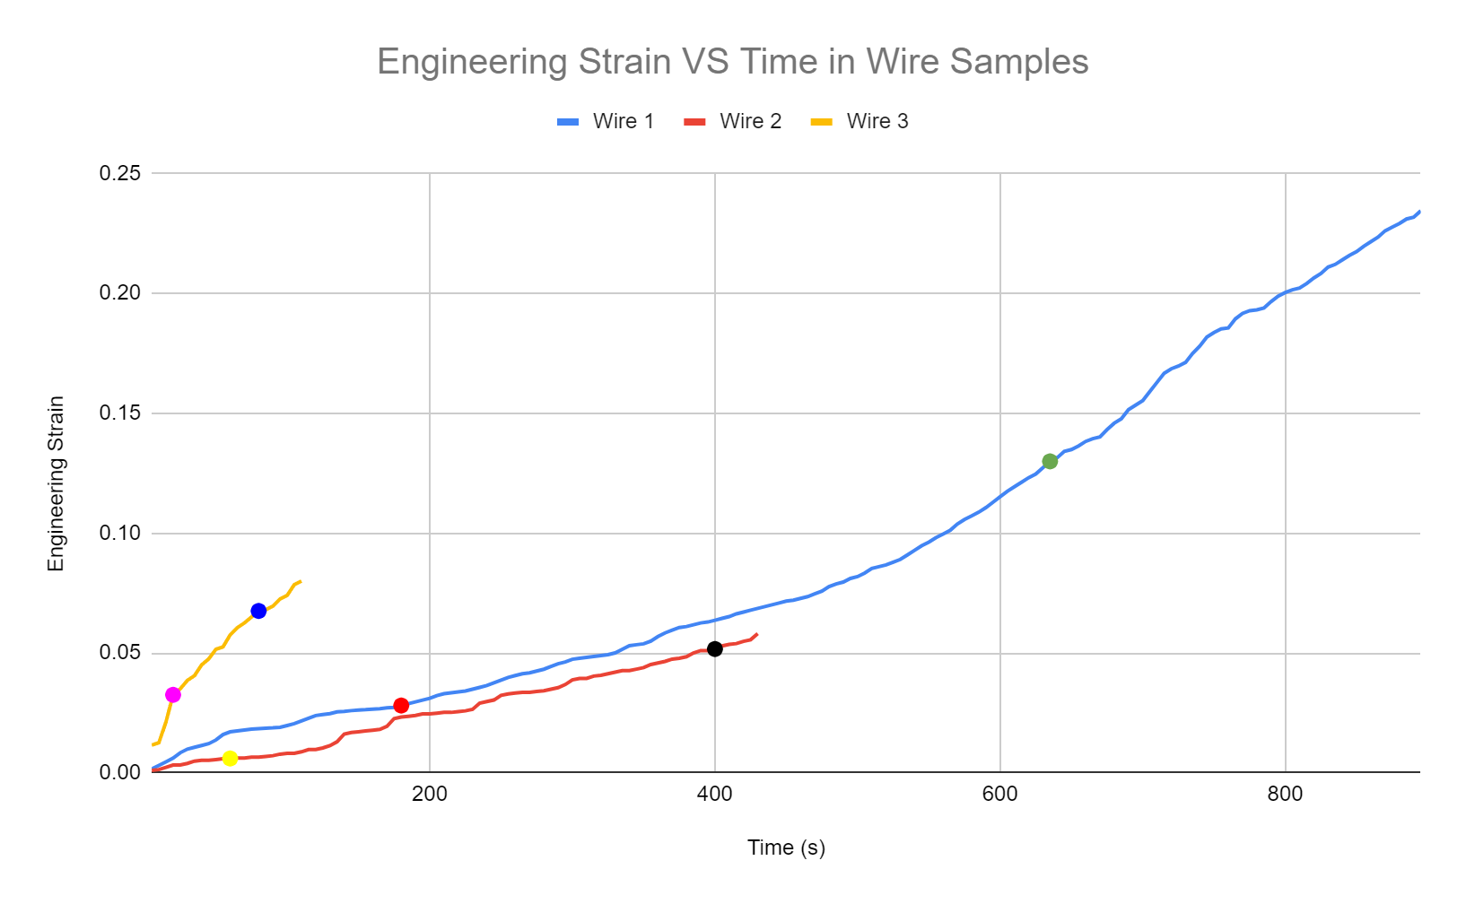



For the first wire (the blue line), the region of primary creep was estimated to be from the beginning of testing to the point on the graph marked in red (at a time of 180 seconds, where a strain of approximately 0.02803 was calculated). The region of secondary creep (i.e. the steady-state region) was estimated to be between the red and green points on the line (the green point marks the time of 635 seconds, corresponding to a calculated engineering strain of 0.1299), while the region of tertiary creep was estimated to be from the green point to the point of fracture.

Similarly, for the second wire (the red line), the region of primary creep was estimated to be from the beginning of the test to the point on the graph marked in yellow (at a time of 60 seconds, where a strain of approximately 0.005935 was calculated). The region of secondary creep (i.e. the steady-state region) was estimated to be between the yellow and black points on the line (the black point marks the time of 400 seconds, corresponding to a calculated engineering strain of 0.05161), while the region of tertiary creep was estimated to be from the black point to the point of fracture.

Lastly, for the third wire (the yellow line), the region of primary creep was estimated to be from the start of the test to the point on the graph marked in pink (at a time of 20 seconds, where a strain of approximately 0.0325 was calculated). The region of secondary creep (i.e. the steady-state region) was estimated to be between the pink and blue points on the line (the green point marks the time of 80 seconds, corresponding to a calculated engineering strain of 0.0675), while the region of tertiary creep was estimated to be from the blue point to the point of fracture.

Using the software MATLAB and the script provided, an estimation of the strain rate for each sample was calculated, along with an approximation of each strain rate’s error. Figs. 2-4 show the outputs of the MATLAB programs, which included the lines of best fit for the steady-state regions of each sample.

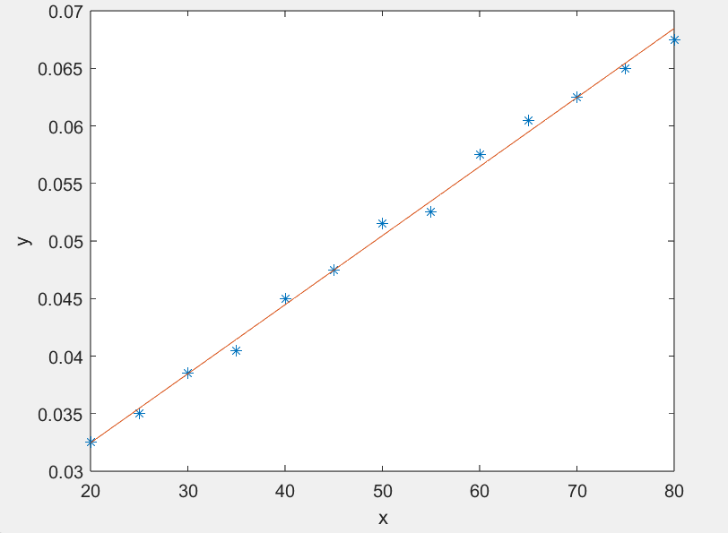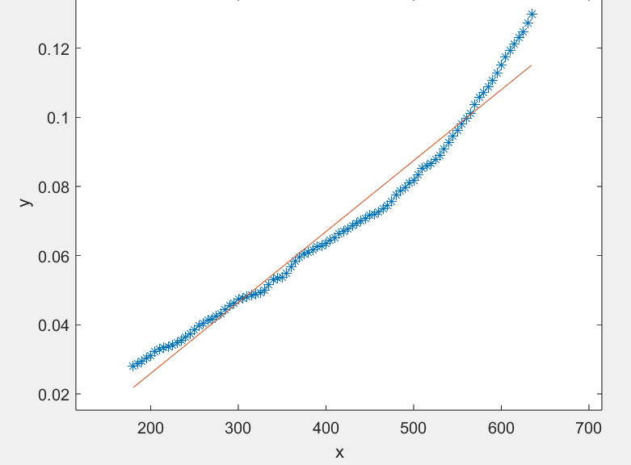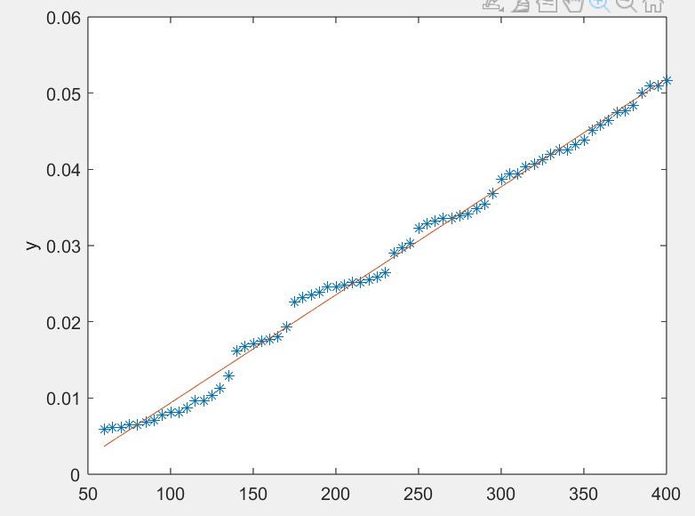



The script used also provided values for the estimated error in the gradient, calculated by finding its standard deviation. Table 1 below summarizes the findings from the MATLAB programs run.

| Wire | Estimated Strain Rate (s-1) | Estimated % Error |
| --- | --- | --- |
| 1 | 2.0513 x 10-4 | 1.9222 |
| 2 | 1.4175 x 10-4 | 1.0060 |
| 3 | 6.0000 x 10-4 | 1.9328 |



Determination of Constants A and n:

Fig. 5 below shows a graph of the logarithms of the calculated strain rates from above against the logarithms of the different stresses experienced by the samples, along with error bars for the three strain rate values. For the values of stress, the area was calculated using the average diameter of the three measured diameters for each wire.

The red point on the graph corresponds to the data point for the first wire, while the green point corresponds to the second wire and the orange corresponds to the third.

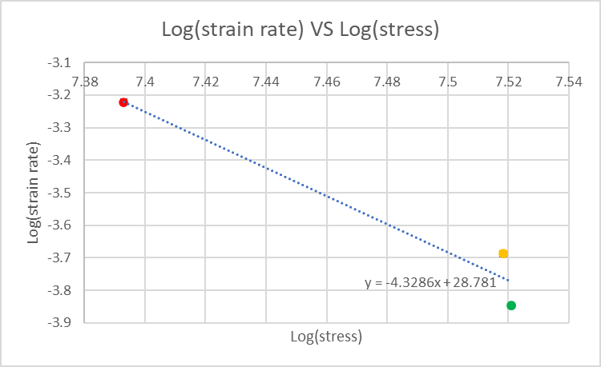



To calculate the values of A and n, the equation given was rearranged to resemble the equation of the trendline of the above graph. Upon this rearrangement, it was seen that the term n could be equated to the gradient of the above graph, while log(A) could be equated to the equation’s y-intercept. These two values were then solved for using the following hand calculations (Fig. 6 below):

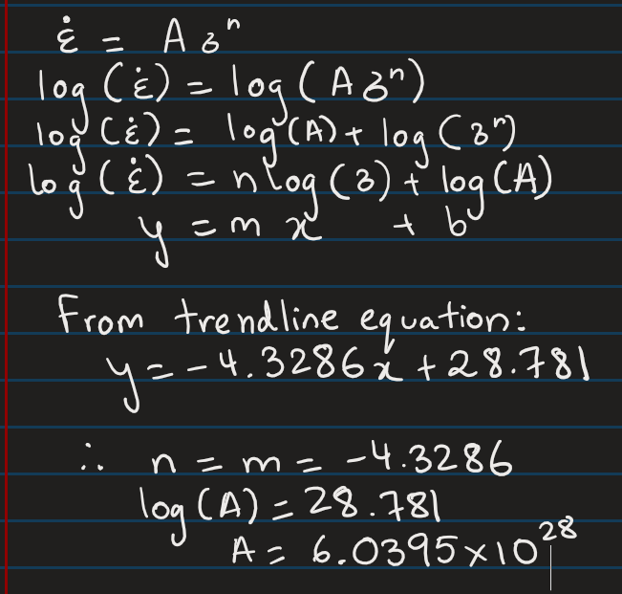



The values of n and A were calculated to be -4.3286 and 6.0395 x 1028 respectively, and the error for n was estimated to be 1.0172 using MATLAB and the script provided once again,.

Total Strain at Failure VS Engineering Stress:

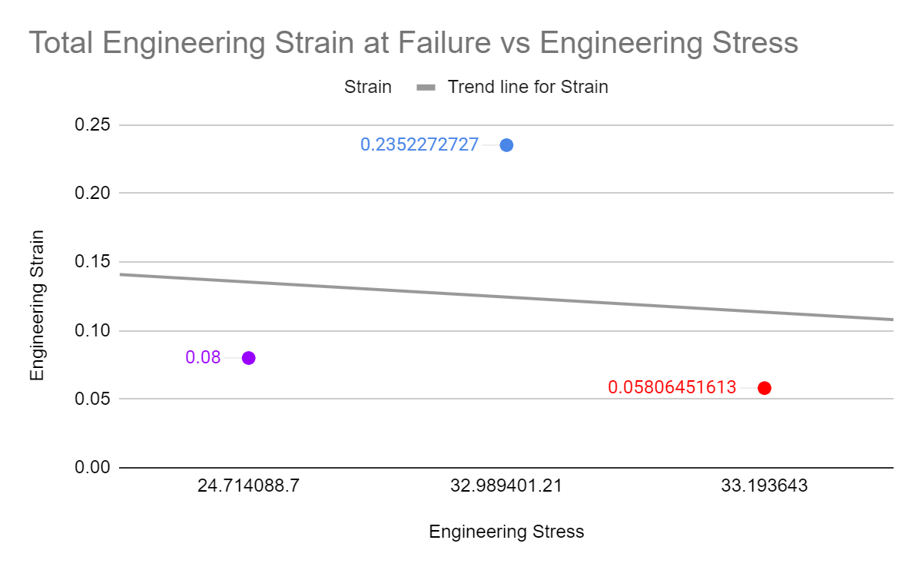



In Fig. 7 shown above, the red dot represents the stress and strain at failure of the second wire, the blue dot represents the first wire and the purple wire represents the third wire in this experiment.

**3.2: Polymers**

Molecular Structures of Polymers:

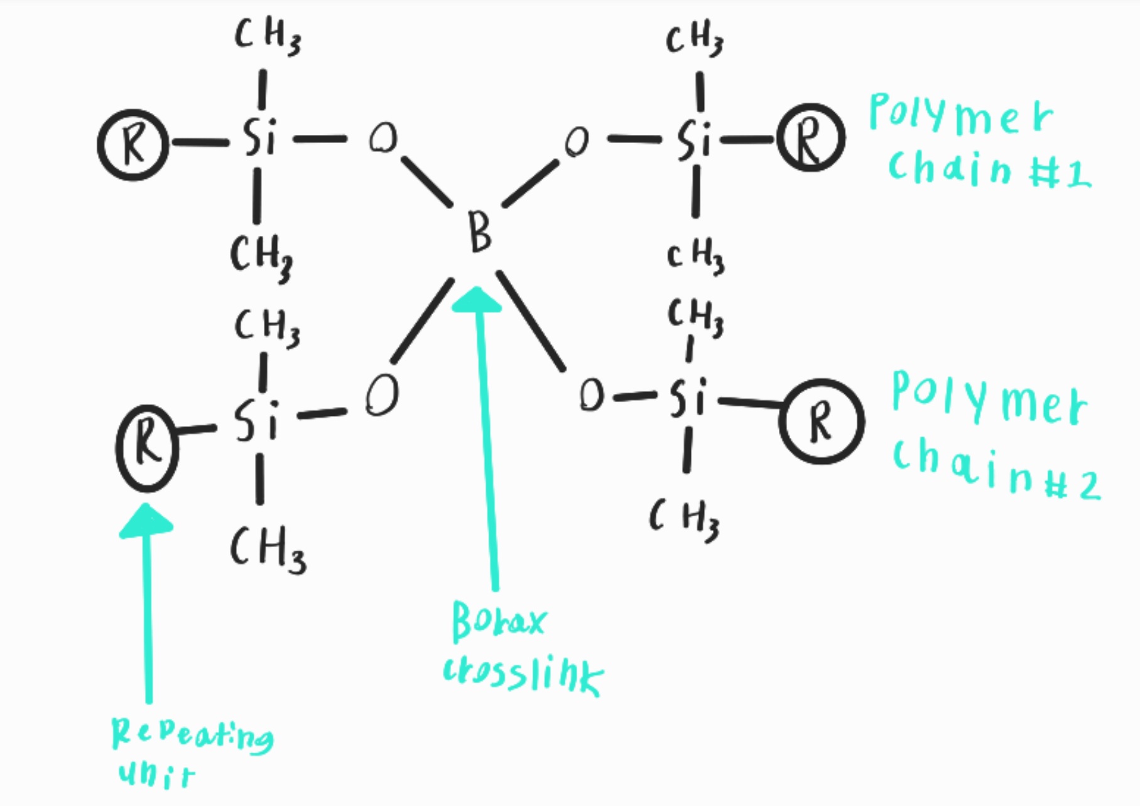



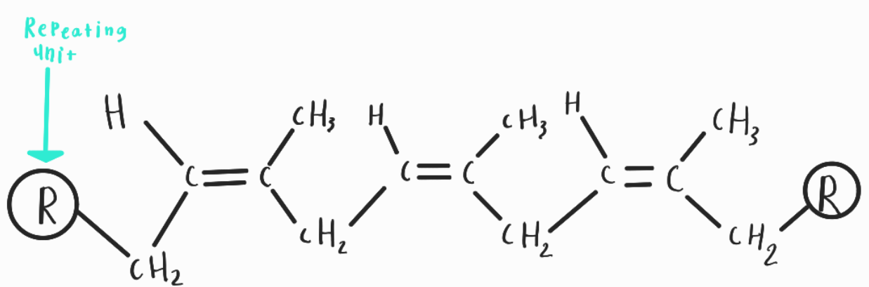



In Fig. 8 the molecular structure of silly putty (polydimethylsiloxane) is shown. In the image, there are borax crosslinks that connect the polymer chains together and maintain the structure. In Fig. 9 the molecular structure of natural rubber (polyisoprene) is shown. R represents the repeated units of the molecular structure.

Effect of Temperature and Strain Rate on Mechanical Properties:

When the silly putty experienced a low strain rate, it was able to stretch a longer distance compared to when a higher strain rate was applied. At a high strain rate, the silly putty was only able to stretch a reduced distance before fracturing. The cross-sectional fracture surface was significantly wider, and had reduced necking when compared to the lower strain rate.

For the experiment with the sample of natural rubber, before it was cooled in a container of liquid nitrogen, it was ductile, flexible and elastic. However, after being immersed and the reduction in its temperature, the rubber became hard and brittle, and broke into pieces upon impact.

**DISCUSSION:**

**4.1: Creep in Metals**

Stages of Creep:

The three stages of creep are primary, secondary and tertiary. In the primary stage, the strain tends to follow behaviour that can be considered almost logarithmic, as the rate of strain decreases with time. The secondary stage is where the strain increases linearly with time, leading to a strain rate that can be considered constant. Finally, the strain in the tertiary creep region increases exponentially with time until the fracture point of the material.

In the first sample, the three stages can be clearly identified. As mentioned in the Results section, the primary region is estimated to be from the start of the test until a time of 180 seconds, where the strain was recorded to be approximately 0.028. The secondary region is estimated to be from a time of 180 seconds to around 635 seconds (corresponding to a strain of approximately 0.130), while the tertiary region is from a time of 635 seconds to 895 seconds, where the sample fractured at a strain of approximately 0.234.

For the second sample, the primary region is estimated to be from the start of the test until a time of 60 seconds, where the strain was recorded to be approximately 0.0059. The secondary region is estimated to be from a time of 60 seconds to around 400 seconds (corresponding to a strain of approximately 0.0516), while the tertiary region is from a time of 400 seconds to 430 seconds, where the sample fractured at a strain of approximately 0.0581.

For the final sample, the primary region is estimated to be from the start of the test until a time of 20 seconds, where the strain was recorded to be approximately 0.0325. The secondary region is estimated to be from a time of 20 seconds to around 80 seconds (corresponding to a strain of approximately 0.0675), while the tertiary region is from a time of 80 seconds to 110 seconds, where the sample fractured at a strain of approximately 0.0800.

It is worth noting that the data for the third wire has limited accuracy due to the wire breaking very early on in the test, which means that the amount of data collected was significantly less than for the other two.

Creep Parameters and Sources of Error:

There were several sources of error during these tests, most of which were experimental. For example, due to the wire being wrapped around the horizontal part of the dead-load creep apparatus, the wire may have slipped within the wrapped rounds, affecting the extension readings taken during the experiment, thus affecting the calculations of strain done after the measurements. This error then would have propagated into the calculations done for log (strain rate) values, which would have finally resulted in errors in values of A and n.

Additionally, during the experiment, the third test was completed with a wire from a different material pool, and had a considerably different diameter. This was due to several test wires breaking from places that made them invalid, which meant the test needed to be redone with a different wire. To compensate for these differences, calculations were done to find a mass that would result in a strain which would produce a curve somewhat comparable to that of the other two wires. The combination of using an estimated equivalent mass and the difference in diameter from the other two tested wires would have resulted in inaccuracies in the stress calculated, which would have affected the relationship between the logarithms of stress and strain rate, thus affecting the equation of the trendline of the graph and therefore the calculated values of A and n.

Lastly, when measuring the diameters of the wires being tested, the diameter from three different points along the wires was measured, and an average of the three was taken. As there was a considerable difference between the three measured diameters for all three wires, this could contribute to experimental errors as well, as these average diameters were used in area calculations when finding the applied stress on each wire’s cross-section. These errors could once again propagate and affect the accuracy of the values of A and n, as the stress applied to each wire was also considered in the calculation of these parameters.

Effect of Load on Creep:

With the increase of load, the engineering stress in each sample increases proportionally, given that the cross sectional area remains the same. On the other hand, the engineering strain at failure has an inversely proportional relationship to load. This happens, given that the material's toughness decreases as the rate of loading increases [4].

It is important to note, however, that wire 3, due to its different dimensions and slightly different material properties (coming from a different material pool), showed unexpected behaviour and has a relatively low strain at failure, even when using a smaller load. To summarise, as seen on Fig. 7, the engineering strain at failure decreases with the increase of stress because when applying a high stress, the material breaks quickly and has less time to plastically deform, resulting in a lower strain at the failure point.

**4.2: Polymers**

Strain-Rate Dependence of Polymers:

Higher strain rates correspond to higher yield stresses. This is because higher strain rates result in the decrease of the molecular mobility of the polymer chains, because it does not allow chains to disentangle as quick deformation limits the time available for the chains to relax or for the chains to slide past each other [5]. Therefore, this means that the polymer will not reach its full elastic potential before plastically deforming.

The reason for the limitation is because higher strain rate means that a large amount of stress is being applied over a short period of time. Since the covalent bonds of the polymers can only accept a certain amount of energy from the applied stress before rupturing, the faster the energy is transferred to those bonds, the more broken bonds there will be in the same amount of time. Therefore, the high intensity of energy from the stress being dispersed through bonds does not allow the strain of the polymer to continue as all those bonds are broken very quickly at the same time, which breaks the polymer chain, not allowing it to reach its highest elastic potential. This factor becomes more apparent for cross-linked polymers as the cross-links inhibit the movements of chains even further, resulting in even more hindered molecular mobility. With its molecular mobility restrained, the polymer’s yield stress increases as more stress needs to be applied in order for it to reach plastic deformation.

On the other hand, low strain rates allow polymer chains to have sufficient time to respond to the applied stress and relax, leading to higher molecular mobility and lower yield stress.

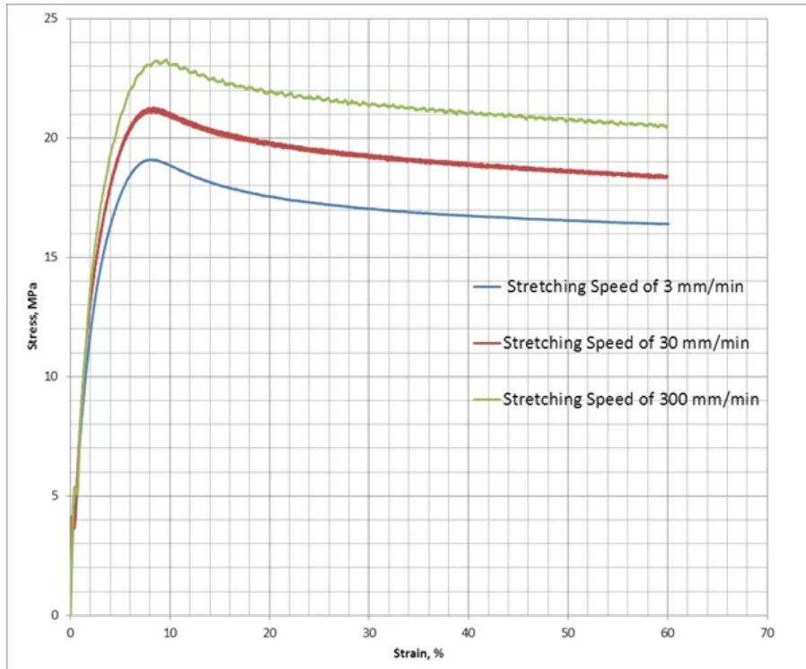



Effect of Temperature on the Properties of Rubber Bands:

The rubber band is a thermoplastic and its mechanical properties change with respect to temperature. As temperature decreases, the distance between polymer chains decreases which makes it more difficult for chains, such as cross-links, branches, and large side groups to move past each other. At lower temperatures, bonding between the chains becomes stronger, which contributes to its leathery behavior where its ductility is lowered, but its strength is stronger. Below the glass transition temperature, the movement of chains becomes extremely difficult and the material becomes hard and brittle.

A reason why winter tires are made from a different composition than all-season or summer tires is because the rubber in summer tires is not created for the purpose of being resistant to the cold in winter. They would cause a safety issue because the rubber becomes less ductile when cooled which increases the possibility of a tire rupture. However, winter tires made from a different composition would have a better endurance against cold temperatures, allowing their ductility to remain when temperature varies.

Trends in Young's Modulus and Density For Different Materials:

Overall, the Young's Modulus of a material is strongly correlated to density. This is clearly shown in the graph, as materials tend to lie on a diagonal, straight line, which implies a directly proportional relationship between Young’s Modulus and density.

Metals and alloys, such as the Sn-Zn wire alloy used in the lab, have significantly higher Young’s Modulus values than polymers, such as the polycarbonate strips from the previous lab. As expected, their densities and Young’s Moduli grew at proportional rates.

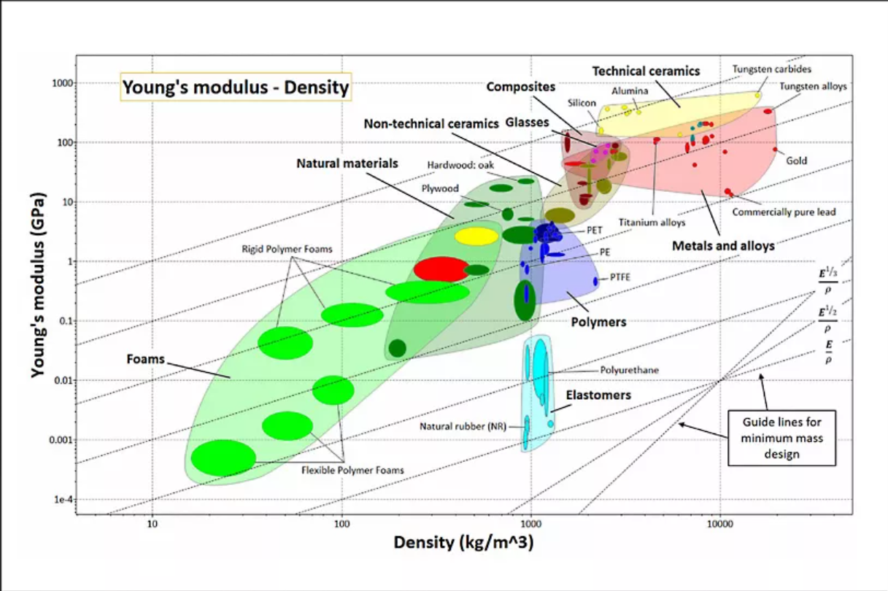



Elastomers, such as polydimethylsiloxane and polyisoprene, have unexpected behaviour and lie outside of the general trend of the graph since they have lower than expected stiffnesses for their given densities. This was made apparent in the lab since a low amount of stress resulted in large plastic deformations on the Silly Putty even though its density was fairly larger than other elements with similar Young’s Modulus such as wood or foam. This happens due to its unusually weak intramolecular forces and viscoelasticity, allowing them to be significantly stretched with low stress [8].

**Safety of Experiment:**

Although the experiment was done in a relatively safe manner, there are several safety factors that could be improved.

In the metal creep experiment, loads of up to 3 kg were suspended above a table by a thin wire. When the wire fractured, the masses fell on the table and were at risk of rolling off the table and potentially hitting group members. This risk was mitigated by wearing closed-toe shoes and maintaining a reasonable distance from the apparatus. An enclosed space (where masses would not be able to roll off) would provide additional safety to the experiment.

During the experiment with the polymers, the rubber sample was submerged in liquid nitrogen in a safe manner. However when it was broken, small shards of the brittle rubber were dispersed around the experiment area in a haphazard manner. This could have resulted in injury as no precautions were taken to avoid impact with the shards.

**Engineering Tools:**

To conduct the experiment to observe creep and determine strain rates, a dead load creep apparatus was used to attach the specimens. Calipers and rulers were used to measure specimens. When experimenting with different polymers, tongs were used to help submerge polyisoprene into liquid nitrogen to reduce the temperature.

**CONCLUSION:**

During the first experiment, the three wires were found to follow the established strain-rate versus time graph with varying degrees of accuracy. The measured values of the diameters of the wires used and the masses used to stretch them were used to calculate values such as the cross-sectional areas of the wires and the stresses experienced. Further, experimental values of the constants A and n from the equation provided were calculated using a graph of log(strain rate) against log(stress), whose trendline showed an inversely proportional relationship (i.e. values of log(strain rate) decreased with increasing values of log(stress)). From calculations done using this graph, the values of A and n were found to be approximately -4.327 and 6.04 x 1028 respectively.

In the second experiment, it was found that the higher the strain rate, the less time it took for the silly putty to plastically deform and fracture. This happens due to the inherent strain-rate sensitivity of polymers, whose total strain is dependent on strain rate, as demonstrated earlier. At a high strain rate, the molecular mobility of the polymers decreases because the intense stress applied breaks covalent bonds at a very fast rate, which limits the elastic extension of the polymer chains. On the other hand, molecular mobility increases at a low strain rate.

In the third experiment, it was found that at a low temperature, the rubber band becomes hard and brittle. The reason for this change in mechanical property of polymer is because the distance between polymer chains shortens, which makes it more difficult for various polymer chains to move past each other or uncoil. This means that as a real-world application, winter tires need to have a different composition than summer tires because of the possibility of a tire rupture.

**REFERENCES**

[1] S. Seethapathy and T. Górecki, "Applications of polydimethylsiloxane in analytical chemistry: A review," Analytica Chimica Acta, vol. 750, pp. 48-62, 2012.

[2] A. Brunning, "Compound Interest," 10 November 2015. [Online]. Available: https://www.compoundchem.com/2015/11/10/sillyputty/. [Accessed 24 July 2023].

[3] H. Agri, “Natural rubber: Structure and function - halcyon: The world’s leading rubber franchise,” Halcyon, https://www.halcyonagri.com/en/natural-rubber-structure-and-function/#:~:text=The%20chemical%20name%20for%20natural,it%20is%20built%20is%20isoprene. (accessed Aug. 1, 2023).

[4] “Toughness,” Nondestructive Evaluation Physics : Materials, https://www.nde-ed.org/Physics/Materials/Mechanical/Toughness.xhtml (accessed Aug. 1, 2023).

[5] Partha Sarathi Mallick and K. Patra, “Impact of cryogenic treatment on mechanical and electro active actuation properties of soft polymers,” Jul. 2023, doi: https://doi.org/10.1002/app.54450.

[6] “High Strain Rate Testing and Characterization of Materials,” *Finite Element Analysis FEA Consulting Services | Hyperelastic Thermoplastics Rubber Composite Material Fatigue Testing Laboratory*, Dec. 16, 2019. https://advanses.com/high-strain-rate-testing-of-materials-part-ii/ (accessed Aug. 03, 2023).

[7] Chart: Young’s modulus vs. density | Ansys, https://www.ansys.com/academic/educators/education-resources/chart-youngs-modulus-vs-density (accessed Aug. 1, 2023).

[8] Admin, “Elastomers: Definition, examples, properties, types, applications,” BYJUS, https://byjus.com/physics/elastomers/#:~:text=The%20molecules%20of%20elastomers%20are,size%20after%20being%20significantly%20stretched. (accessed Aug. 2, 2023).